**HLS Acc. Phys Magnet App (v1)**

|  |  |
| --- | --- |
| **Task Name:** | HLS Acc. Phys Magnet App (v1) |
| **Principal Investigator:** | Duncan Scott |
| **Task Type:** | High Level Software |
| **Task Description:** | AP magnet app for load/ save, all on all of, degauss, etc. Extension to similar app on VELA, |

# Document History

|  |  |  |  |
| --- | --- | --- | --- |
| Swim Lane | Date | Reviewer | Authors |
| Specification | 30/09/2016 | Deepa Angal-Kalinin | DJ SCOTT |
| Design | Date | Approver |  |
| Implementation | Date | Approver |  |
| Feedback | Date | Approver |  |

# Aims/Specification

|  |  |  |  |  |  |  |  |  |  |  |  |  |  |  |  |
| --- | --- | --- | --- | --- | --- | --- | --- | --- | --- | --- | --- | --- | --- | --- | --- |
| **Agreed Outcomes**  *List all specifications required in the design phase* | |  |  | | --- | --- | | No. | Outcome | | 1 | in PYQT with: | | 2 | Monitor different machine areas (VELA_INJ, CLARA_Inj etc) | | 3 | Handle different machine modes, (Virtual, Physical, offline) | | 4 | Save and Apply DBURTS | | 5 | Degauss | | 6 | 1 click on / off | |

# Method/Design

## Sourcecode, Class Structure and Design

* **From the git repo “\Software\MagnetApp\”**
* **Uses magnetController library, PyQt**
* **GUI classes except LOAD view built with QTDesigner, with raw .ui files**
* **All source-code also Project contained in PyCharm IDE**
* **No logging in this app. It does not calibrate or take data, it’s a simple app to interface via GUI with the main functions built into the magnetController.**
* **Expected issues during commissioning are, fitting in the CLARA phase 1 machine parameter names, (probably extend to have magnet name + section, i./e. “S01-QUAD-01” and “SO2-QUAD-01” etc.**

**Class hierarchy**

(Read Only)

**magnetAppController**

* interface between GUI classes and magnetController

**dburtLoadView (GUI)**

* preview dburt
* load dburt, for all magnets, quads only, corr only

**dburtSaveView (GUI)**

* save DBURT with comments keywords /

**magnetController**

* Flavour determined by **startView** choices
* Control / monitor selected magnetsArea

**mainView (GUI)**

* Monitor Mags (Mags determined by flavour of **magnetController**

**magnetWidget (GUI)**

* Bespoke widget to monitor / control magnet parameters
* 1 per magnet

**Main**

**magnetApp**

init QtGui.QWidget

**startView (GUI)**

* Chose machine mode and Area

**magnetObject** (Reference)

1 per magnet  for each magnet in the controller

Most GUI buttons are connected in the magnetAppController (some simple functions like ***select all*** in mainView are handled local to that class.

There is no threading, there are no complex procedures performed by this app all the function calls are to the magnetController.

Most function calls are trivial and directly follow from button clicking.

GUI updating happens via a QT timer that calls update on each magnetWidget every 200ms. Each magnetWidget holds a magnetObject reference and when update is called the latest values are accessed and the magnetWidget updates itself.

GUI Panels

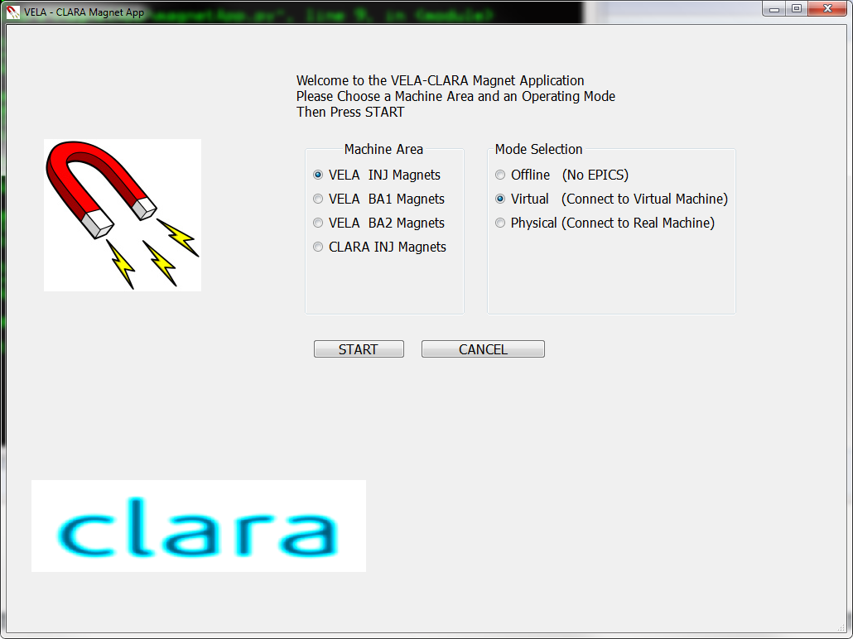

startView, radio buttons select Machine Mode and Area

From this correct magnetController is instantiated and mainView built

mainView, monitor magnets (individual magnetWidgetinstancefor each magnet). Main buttons perform basic operations on selected magnets. “All ...” buttons work whether magnet is selected or not

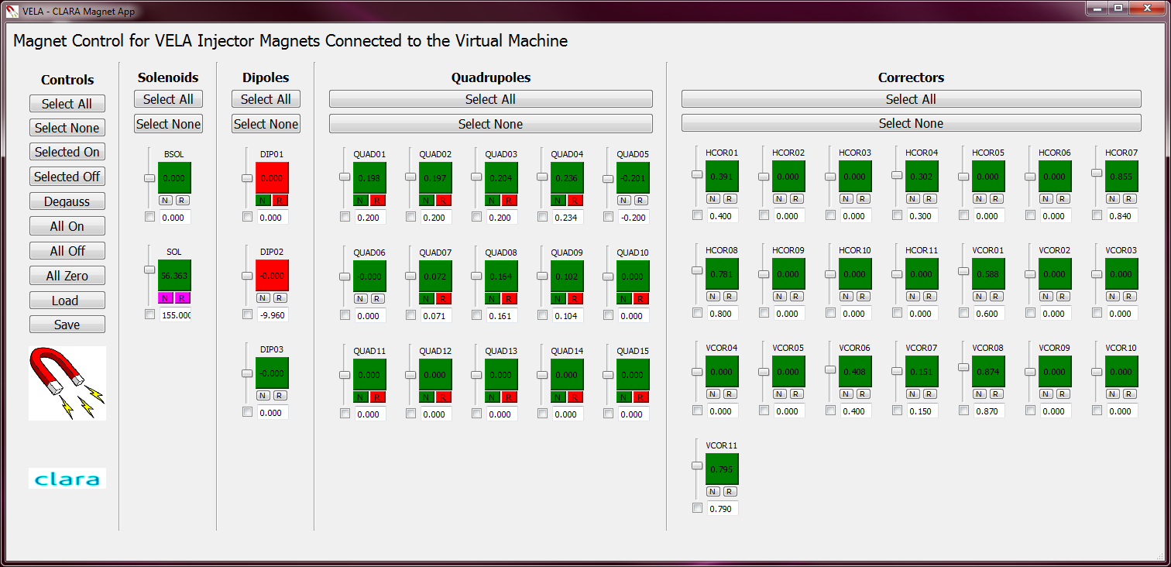

**dburtLoadView.** File selector, View, shows file (RHS example)

radio button to apply file to different magnets

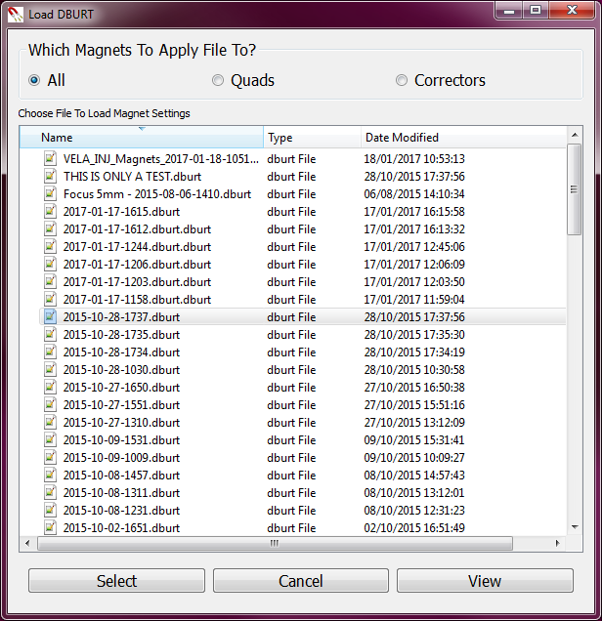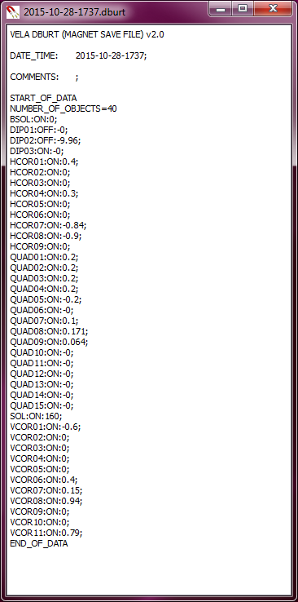

**dburtSaveView.** Default file name includes machine area and date time. Keywords and comments get appended to start of file

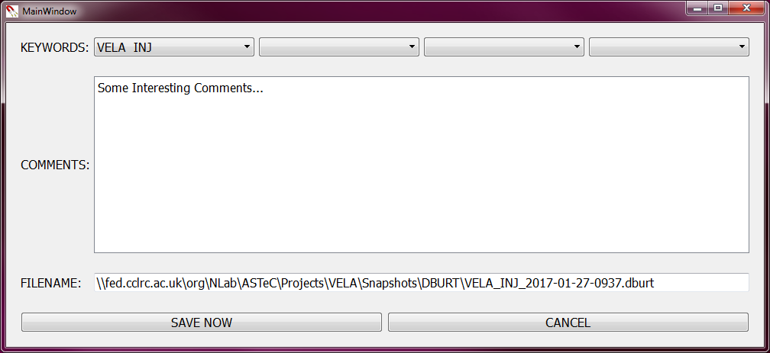

|  |  |  |  |  |  |  |  |  |  |  |  |  |  |  |  |
| --- | --- | --- | --- | --- | --- | --- | --- | --- | --- | --- | --- | --- | --- | --- | --- |
| **Achieved Outcomes**  *These should map 1-to-1 to the aims/specifications* | |  |  | | --- | --- | | No. | Outcome | | 1 | in PYQT with: | | 2 | Monitor different machine areas (VELA_INJ, CLARA_Inj etc) | | 3 | Handle different machine modes, (Virtual, Physical, offline) | | 4 | Save and Apply DBURTS | | 5 | Degauss | | 6 | 1 click on / off | |

# Results/Implementation

Results and implementation described here.

* For Simulation/Experimental tasks:
  + This should be a standard “results” section of a report.
  + Describe the results of your simulation/experiment using relevant media.
  + You may provide a link to a VELA/CLARA experimental report if relevant.
* For Software tasks:
  + This should describe the implementation of the software onto the real machine.
  + It should detail the actions and usage scenarios of the software.
  + This section should be able to act as a manual for your software.
* For Planning tasks:
  + This should provide an overview of the plan, including timescales and personnel.
  + Flow diagrams or other media should be included where relevant.

# Conclusion/Feedback

Conclusions and feedback described here.

* For Simulation/Experimental tasks:
  + This should be a standard “conclusion” section of a report.
  + Describe the outcomes of your simulation/experiment and any actions or new tasks arising from the results presented in Section 4.
* For Software tasks:
  + This should describe any feedback received upon usage of the software.
  + Changes and additions that need to be made should generate new tasks and/or software versions.
  + This section may act as the Aims/Specification for a new version of your software.
* For Planning tasks:
  + This should describe all potential tasks derived from the master plan given in Section 4.

In general the feedback section should be used to generate new Tasks dependent on the output of this task.

|  |  |  |  |  |  |  |  |  |  |  |  |  |  |  |  |  |  |  |  |  |  |  |
| --- | --- | --- | --- | --- | --- | --- | --- | --- | --- | --- | --- | --- | --- | --- | --- | --- | --- | --- | --- | --- | --- | --- |
| **New Tasks**  *These should produce new Workflow tasks* | |  |  |  | | --- | --- | --- | | No. | Task Name | Description | | 1 |  |  | | 2 |  |  | | 3 |  |  | | 4 |  |  | | 5 |  |  | | 6 |  |  | |